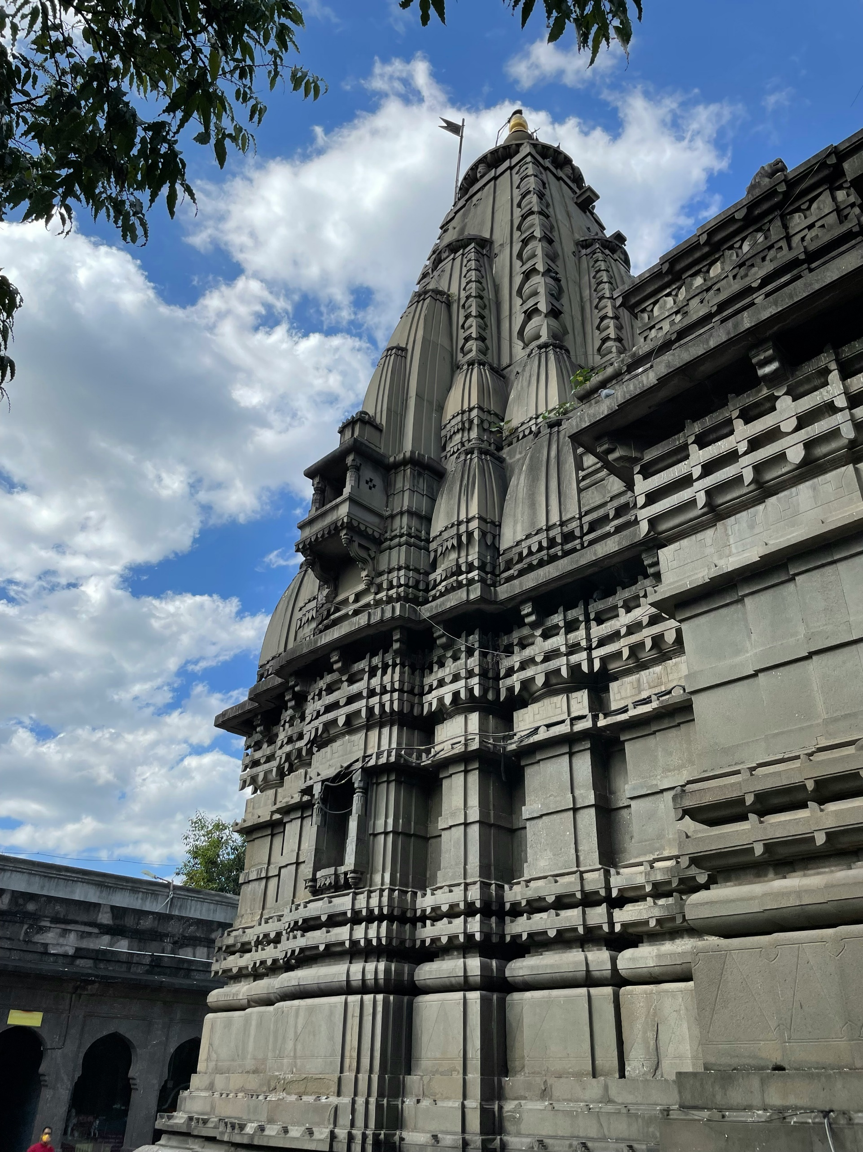

|  |
| --- |
| Tourism Of Nashik |
|  |
| June 27  Netleap  Authored by: Siddhesh More |

# Introduction

|  |
| --- |
| Introduction To Tourism of Nashik Tourism of Nashik is an innovative online platform designed to offer comprehensive information and services to tourists and locals interested in exploring the vibrant city of Nashik. Known for its rich cultural heritage, beautiful landscapes, and renowned vineyards, Nashik is a prime destination for travelers. Our website serves as a one-stop resource, providing detailed insights into the city's attractions, including local cuisine, accommodations, and popular tourist spots.  Key features of the Tourism of Nashik website include: |
| **Informative Content**: Visitors can explore extensive information about Nashik's famous food, hotels, and local areas. This helps them plan their trip effectively and ensures they do not miss out on any significant experiences.  **Tour Booking Services**: For those looking to visit Nashik, we offer a seamless tour booking option. Users can easily book a tour through our website, and we ensure they receive the best tour guide to enhance their experience.  **Expert Tour Guides**: We pride ourselves on providing knowledgeable and professional tour guides. Our guides are well-versed in Nashik's history, culture, and hidden gems, making each tour memorable and enriching.  **Guide Job Applications**: We also provide an opportunity for individuals passionate about Nashik to join our team as tour guides. Aspiring guides can apply for a job through our website, offering their expertise and love for the city to visitors. |
| Tourism of Nashik aims to create a user-friendly, informative, and engaging platform that not only promotes the city's tourism but also supports the local community by offering job opportunities. Our goal is to enhance the overall experience of every visitor to Nashik, ensuring they leave with unforgettable memories and a deep appreciation for the city's charm. |

Objective

## Objective of Tourism of Nashik

**Provide Comprehensive Information:**

To offer detailed and accurate information about Nashik's attractions, including local cuisine, hotels, and key tourist spots, helping visitors plan their trips effectively.

**Facilitate Easy Tour Bookings:**

To create a seamless and user-friendly tour booking system that allows visitors to easily schedule and book tours with the best available guides.

**Offer Professional Tour Guides:**

To ensure that tourists have access to knowledgeable and professional tour guides who can provide enriching and memorable experiences during their visit to Nashik.

**Promote Local Tourism:**

To boost local tourism by highlighting Nashik's unique cultural, historical, and natural attractions, encouraging more visitors to explore the city.

**Support Local Employment:**

To create job opportunities for locals by allowing them to apply for positions as tour guides, thereby supporting the local economy and community.

**Enhance User Experience:**

To continuously improve the website's functionality and user experience, making it easy for visitors to find information, book tours, and apply for guide positions.

**Foster Community Engagement:**

To build a community of travelers and locals who share their experiences, reviews, and recommendations, creating a vibrant and interactive platform.

practices that preserve Nashik's cultural heritage and natural beauty for future generations.

System Analysis and Requirement

## System Analysis and Requirement for Tourism of Nashik

Methodology Development Model

The development of the "Tourism of Nashik" website will follow a structured methodology, leveraging technologies such as XAMPP, phpMyAdmin, HTML, PHP, CSS, JavaScript, Git, and GitHub. The process involves several key phases: planning, analysis, design, development, testing, deployment, and maintenance.

**1.Planning Phase**

* **Objective Setting:** Define the goals of the project, including providing comprehensive information about Nashik, facilitating tour bookings, and offering guide job opportunities.
* **Feasibility Study:** Assess the project's feasibility in terms of technical, economic, and operational aspects.
* **Resource Allocation:** Allocate necessary resources, including budget, team members, and tools.
* **Project Timeline:** Develop a detailed project timeline with clear milestones and deadlines.

**2. Analysis Phase**

* **Requirement Gathering:** Collect detailed requirements from stakeholders, including users, local businesses, and tour guides.
* **Market Research:** Conduct research to understand the needs and preferences of target users and analyze competitors.
* **Functional Specifications:** Document the required features and functionalities of the website.

**3. Design Phase**

* **User Interface Design:** Create wireframes and mockups for the website’s interface using HTML, CSS, and JavaScript.
* **Database Design:** Design the database schema using phpMyAdmin to store information about users, tours, guides, bookings, and more.
* **System Architecture:** Define the system architecture, selecting XAMPP for the development environment and determining the overall structure of the website.

**4. Development Phase**

* **Front-End Development:** Implement the user interface using HTML, CSS, and JavaScript to ensure a responsive and user-friendly design.
* **Back-End Development:** Develop the server-side logic using PHP, integrating it with the MySQL database managed through phpMyAdmin.
* **Version Control:** Use Git for version control and GitHub for code repository management, facilitating collaboration and code tracking.
* **Integration:** Ensure seamless interaction between the front-end and back-end components.

5. **Testing Phase**

* **Unit Testing:** Test individual components and modules to ensure they function correctly.
* **Integration Testing:** Test the integrated system to identify any issues arising from the interaction between different components.
* **User Acceptance Testing (UAT):** Conduct UAT with potential users to gather feedback and ensure the website meets their needs.
* **Bug Fixing:** Identify and fix any bugs or issues discovered during testing.

**6. Deployment Phase**

* **Hosting Setup:** Set up the hosting environment using XAMPP, ensuring it is secure, scalable, and reliable.
* **Data Migration:** Migrate necessary data to the live environment.
* Go-Live: Launch the website and make it accessible to users.

**7. Maintenance Phase**

* **Monitoring:** Continuously monitor the website’s performance, security, and user feedback.
* **Updates:** Regularly update the website with new content, features, and improvements based on user feedback and technological advancements.
* **Support:** Provide ongoing technical support to resolve any issues users may encounter.

Tools and Technique

Tools

**Figma:** A web-based UI/UX design tool used for creating user interfaces and experiences. Figma allows for real-time collaboration and prototyping, making it easy to design and iterate on website layouts and interactions.

**XAMPP:** An open-source web server solution stack package developed by Apache Friends, XAMPP includes Apache HTTP Server, MariaDB (or MySQL), and interpreters for scripts written in PHP and Perl. It is used for local development and testing of web applications.

**phpMyAdmin:** A free and open-source tool written in PHP intended to handle the administration of MySQL over the web. It supports a wide range of operations on MySQL and MariaDB, allowing database management tasks to be performed easily.

**HTML (HyperText Markup Language):** The standard markup language for documents designed to be displayed in a web browser. HTML is used for structuring web pages and web applications.

**CSS (Cascading Style Sheets):** A style sheet language used for describing the presentation of a document written in HTML or XML. CSS enhances the appearance and layout of web pages.

**JavaScript:** A high-level, interpreted programming language that conforms to the ECMAScript specification. It is used to create interactive effects within web browsers, enhancing the user experience.

**PHP (Hypertext Preprocessor):** A popular general-purpose scripting language that is especially suited to web development. PHP scripts are executed on the server, enabling dynamic content generation and database interactions.

**Git:** A distributed version control system designed to handle everything from small to very large projects with speed and efficiency. Git tracks changes in source code during software development.

**GitHub:** A web-based platform used for version control and collaborative software development. It allows multiple people to work together on projects, track changes, and manage versions.

Technique

**Agile Development:** A methodology that promotes continuous iteration of development and testing throughout the software development lifecycle. Agile enables flexible responses to change and involves collaboration among cross-functional teams.

**Responsive Web Design:** An approach to web design that makes web pages render well on a variety of devices and window or screen sizes. This technique ensures a good user experience across desktops, tablets, and mobile devices.

**MVC (Model-View-Controller) Architecture:** A software design pattern commonly used for developing user interfaces that divides the related program logic into three interconnected elements: Model, View, and Controller. This helps in separating concerns and improving code maintainability.

**Database Normalization:** A process used to organize a database into tables and columns to reduce redundancy and improve data integrity. It involves dividing large tables into smaller, manageable pieces while maintaining relationships between them.

**Version Control Workflow:** A set of practices for using Git and GitHub to manage changes to the source code. This includes branching, merging, pull requests, and conflict resolution, ensuring a smooth and organized development process.

**Cross-Browser Compatibility Testing:** The practice of ensuring that a web application works as expected in different web browsers. This involves testing the website on multiple browsers and fixing any compatibility issues that arise.

**User-Centered Design:** A design philosophy and a process in which the needs, wants, and limitations of end-users are given extensive attention at each stage of the design process. It aims to create more effective and user-friendly interfaces.

**Continuous Integration and Deployment (CI/CD):** A practice in software engineering that involves automatically testing and deploying code changes. CI/CD ensures that code changes are reliable and can be deployed to production frequently.

Specification Requirement

**Hardware:**

Windows or Unix OS

Desktop/Laptop Computer

**Software:**

VS Code

XAMPP

Git

Github Desktop

Logical Database

The logical database design for the "Tourism of Nashik" project involves organizing the data into a series of tables, ensuring data integrity, and establishing relationships between tables. The design focuses on four main entities: Admins, Employees, Tour Assignments, and Users. Below is an outline of each table's structure, including primary keys, foreign keys, and data types.

**Tables and Relationships**

**Admin Table**

Stores information about administrators of the website.

|  |  |  |
| --- | --- | --- |
| Column | Data Type | Description |
| id | INT(22) | Primary Key |
| aname | VARCHAR(50) | Admin username |
| apass | VARCHAR(250) | Admin password |
| date | DATE | Date of record creation |

**Emp Table**

Stores information about employees (tour guides).

|  |  |  |
| --- | --- | --- |
| Column | Data Type | Description |
| emp_id | INT(22) | Primary Key |
| emp_name | VARCHAR(70) | Employee name |
| emp_email | VARCHAR(70) | Employee email |
| emp_phone | VARCHAR(70) | Employee phone |
| emp_type | VARCHAR(70) | Employee type |
| emp_age | VARCHAR(70) | Employee age |
| emp_gender | VARCHAR(70) | Employee gender |
| emp_pass | VARCHAR(270) | Employee password |
| emp_date | DATE | Date of record creation |
| is_free | INT(22) | Employee availability |